Manav Rachna University

DBMS PROJECT

STUDENT RECORD MANAGEMENT SYSTEM

Project by:

Ankit (1012)

Ankush (1013)

Akshat (1008)

**ER – Diagram**

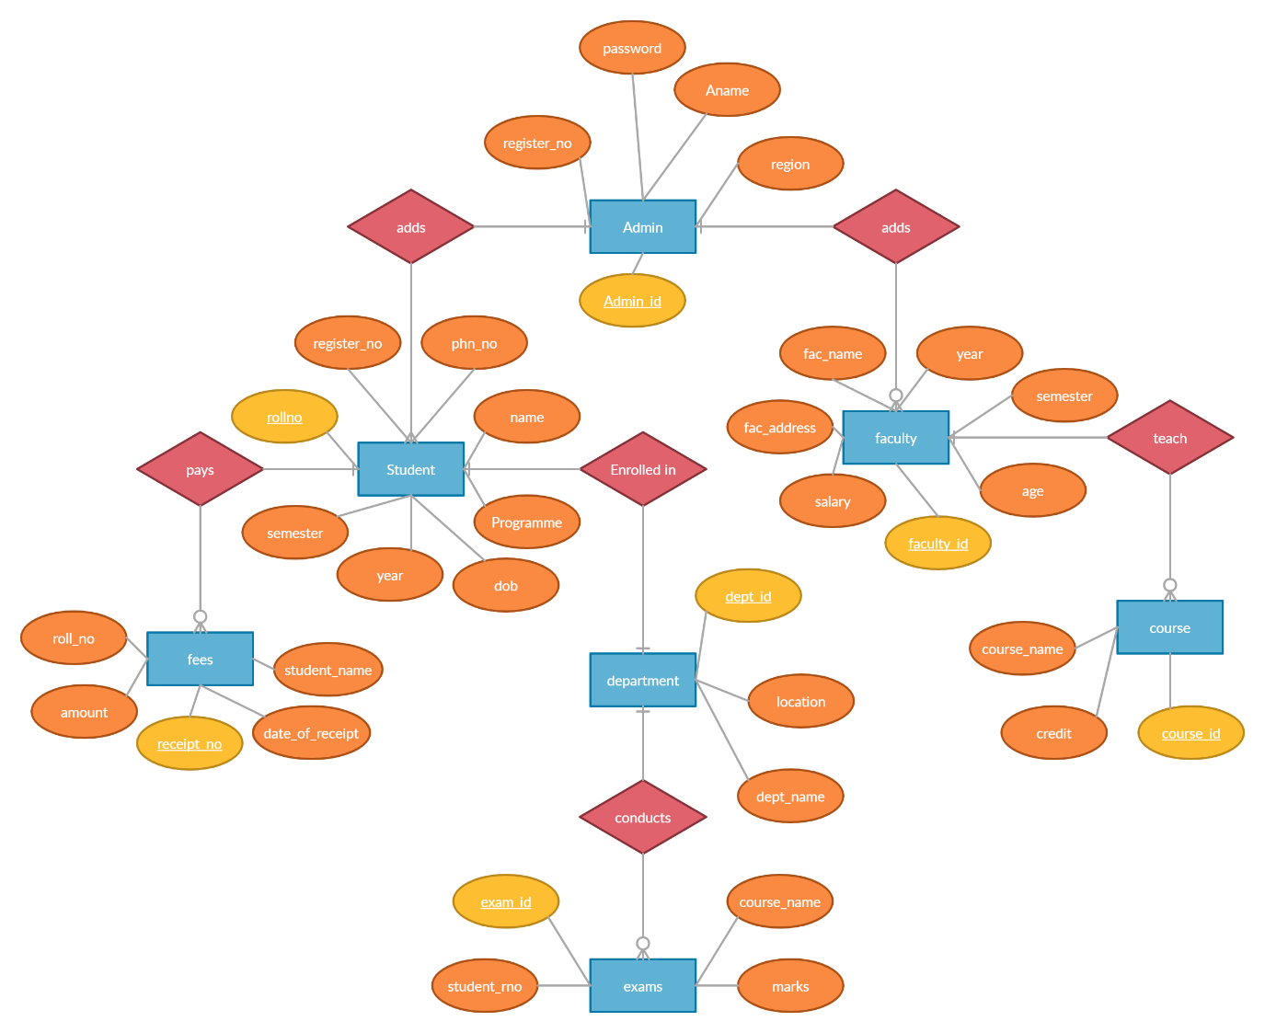

**Queries**

MariaDB [(none)]> create database Student_Management;

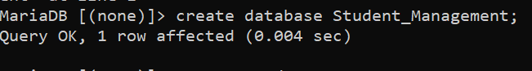

MariaDB [student_management]> create table admin

-> (admin_id char PRIMARY KEY,

-> A_name varchar(20) NOT NULL,

-> Password varchar(20),

-> register_no int,

-> region varchar(10));

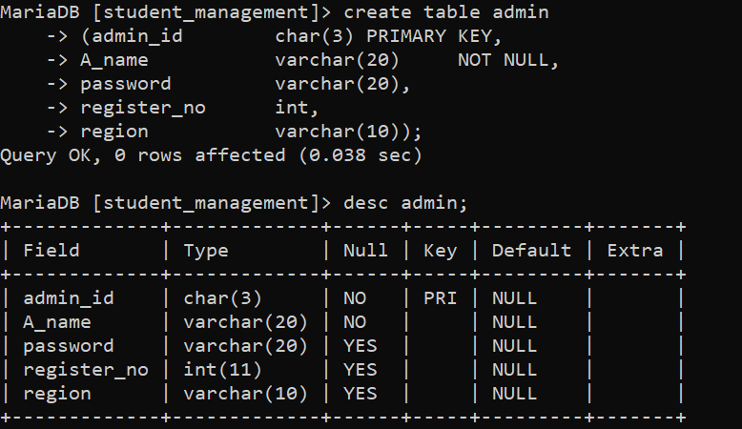

MariaDB [student_management]> create table student

-> (rollno varchar(10) PRIMARY KEY,

-> S_name varchar(20) NOT NULL,

-> Phn_no int,

-> reg_no int,

-> dob date,

-> year int,

-> semester int,

-> programme varchar(10));

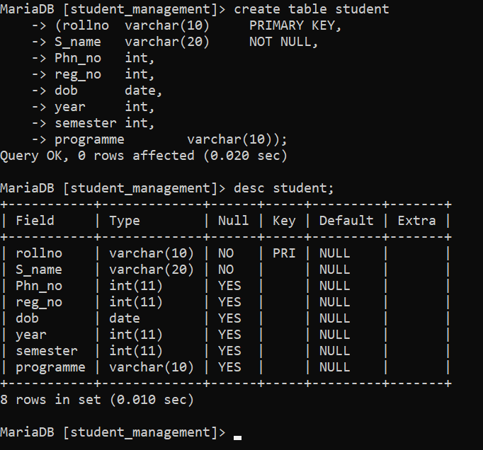

MariaDB [student_management]> create table fees

-> (rollno varchar(20),

-> amount int,

-> receipt varchar(10) PRIMARY KEY,

-> student_name varchar(20),

-> date_of_receipt date);

Query OK, 0 rows affected (0.020 sec)

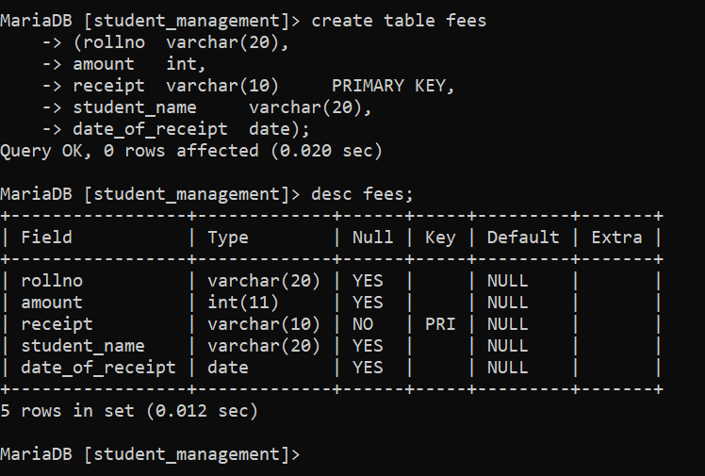

MariaDB [student_management]> create table faculty

-> (faculty_id char PRIMARY KEY,

-> fac_name varchar(20),

-> fac_address varchar(20),

-> age int,

-> salary int,

-> year int,

-> semester int);

Query OK, 0 rows affected (0.021 sec)

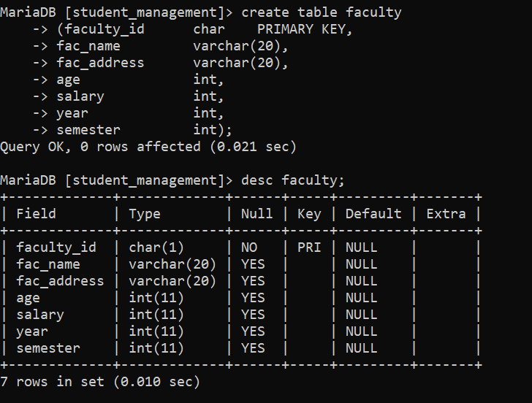

MariaDB [student_management]> create table course

-> (course_id char PRIMARY KEY,

-> course_name varchar(20),

-> credits int);

Query OK, 0 rows affected (0.021 sec)

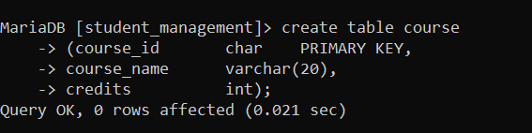

MariaDB [student_management]> create table department

-> (dept_id char PRIMARY KEY,

-> dept_name varchar(20),

-> location varchar(10)

-> );

Query OK, 0 rows affected (0.021 sec)

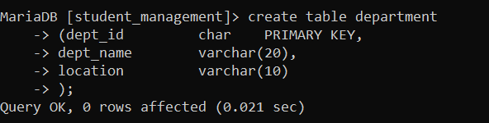

MariaDB [student_management]> create table exams

-> (exam_id char PRIMARY KEY,

-> exam_name varchar(20),

-> marks int,

-> student_rno varchar(10));

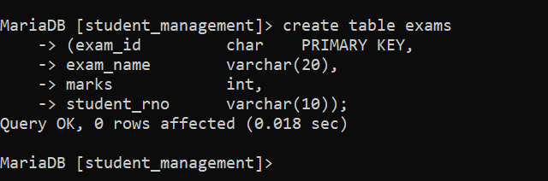

MariaDB [student_management]> show tables;

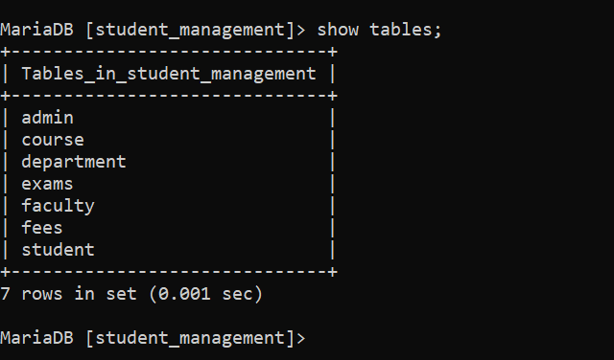

MariaDB [(none)]> use student_management;

Database changed

MariaDB [student_management]> insert into student

-> values('ABC001', 'Ram', 1299230229, 19921, '2000/02/19', 2, 3, 'BTECH');

Query OK, 1 row affected (0.009 sec)

MariaDB [student_management]> insert into student

-> values('ABC002', 'Akash', 1299433229, 19925, '2001/09/29', 2, 3, 'BTECH');

Query OK, 1 row affected (0.003 sec)

MariaDB [student_management]> insert into student

-> values('ABC003', 'Bhavesh', 9999433231, 19955, '2000/12/12', 2, 3, 'BTECH');

Query OK, 1 row affected, 1 warning (0.003 sec)

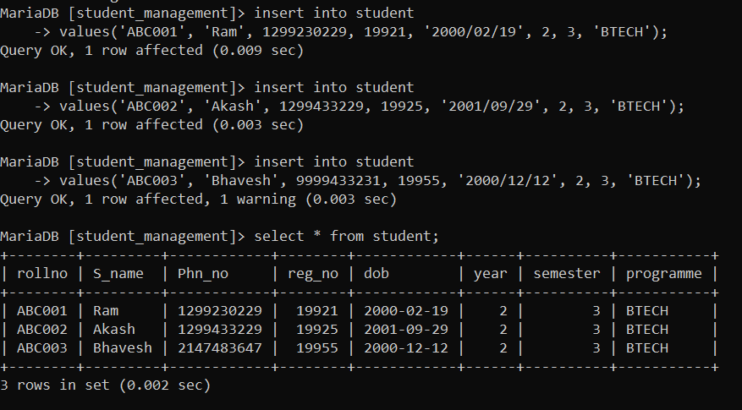

MariaDB [student_management]> update student

-> set year=3

-> where rollno='ABC001';

Query OK, 1 row affected (0.006 sec)

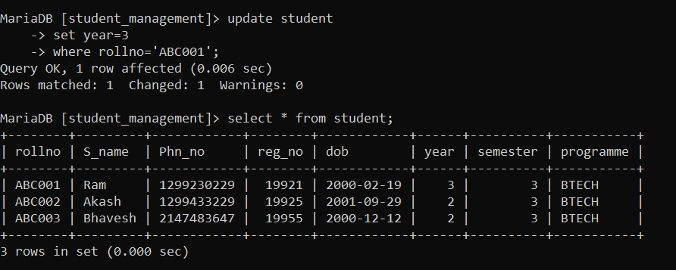

MariaDB [student_management]> delete from student

-> where rollno='ABC003';

Query OK, 1 row affected (0.004 sec)

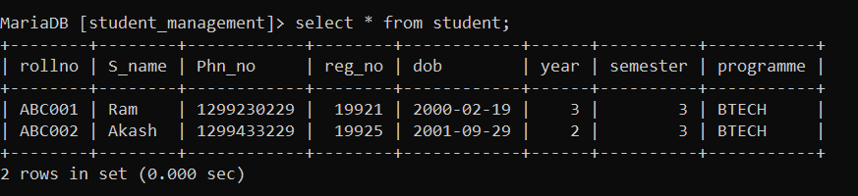

MariaDB [student_management]> insert into course

-> values('c01', 'DBMS', 4);

Query OK, 1 row affected (0.021 sec)

MariaDB [student_management]> insert into course

-> values('c02', 'OOPs using JAva', 4);

Query OK, 1 row affected (0.020 sec)

MariaDB [student_management]> insert into course

-> values('c03', 'ADA', 3);

Query OK, 1 row affected (0.003 sec)

MariaDB [student_management]> select * from course;

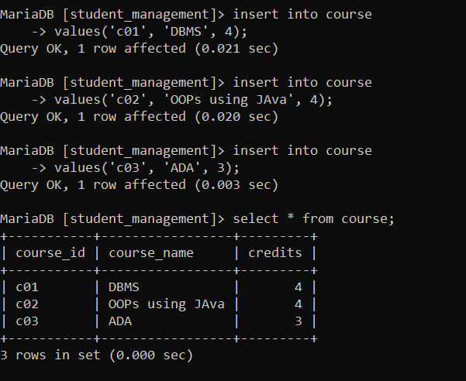

MariaDB [student_management]> insert into department values

-> ('d01', 'CST', 'L Block'),

-> ('d02', 'LAW', 'G Block');

Query OK, 2 rows affected (0.003 sec)

Records: 2 Duplicates: 0 Warnings: 0

MariaDB [student_management]> select * from department;

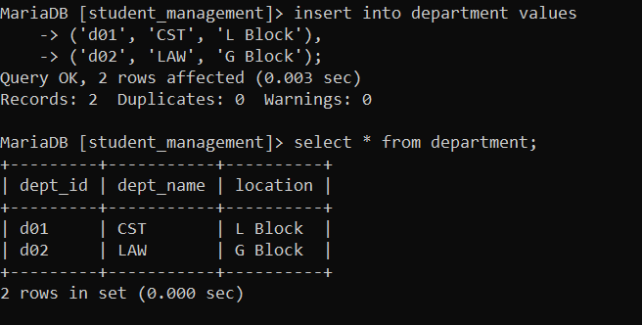

MariaDB [student_management]> update department

-> set location='K Block'

-> where dept_id = 'd02';

Query OK, 1 row affected (0.010 sec)

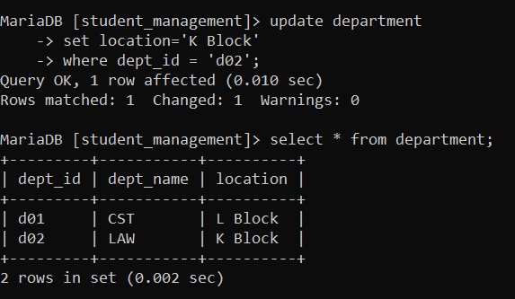

MariaDB [student_management]> delete from course

-> where course_id='c01';

Query OK, 1 row affected (0.003 sec)

